WEEK 6 ASSIGNMENT:

1;

Create a new React Application with the name “myfirstreact”, Run the application to print “welcome to the first session of React” as heading of that page

Progrma:

App.jsx:

import React from "react";

import './App.css';

function App() {

return (

<div className="App">

<h1>Welcome to Day 11</h1>

<p>This is a simple React application.</p>

</div>

);

}

export default App;

App.css

.App{

text-align: center;

font-family: Arial, sans-serif;

background-color: #f0f0f0;

padding: 20px;

}

Photo: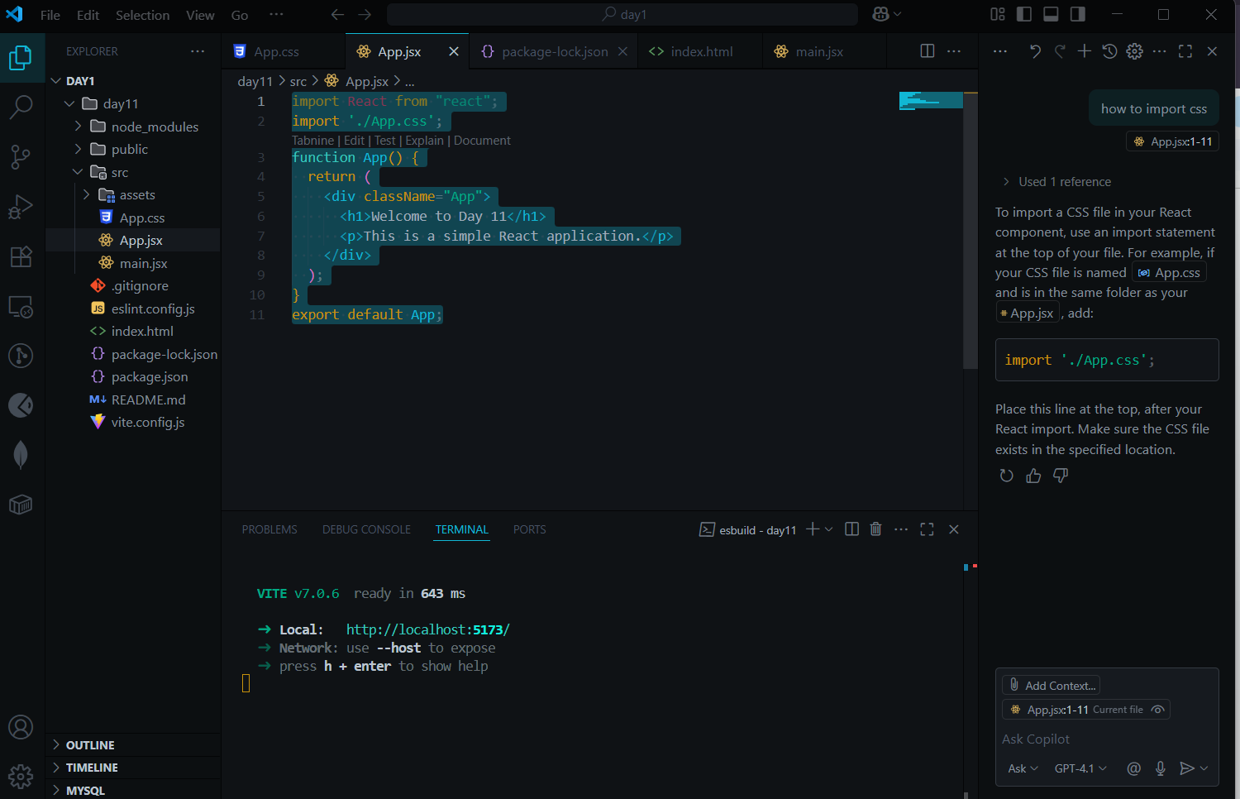

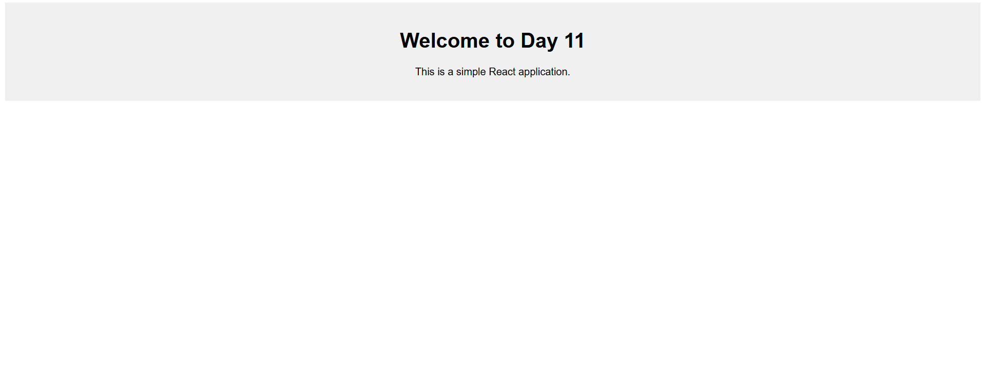2.Create a react app for Student Management Portal named StudentApp and create a component named Home which will display the Message “Welcome to the Home page of Student Management Portal”. Create another component named About and display the Message “Welcome to the About page of the Student Management Portal”. Create a third component named Contact and display the Message “Welcome to the Contact page of the Student Management Portal”. Call all the three components.  
Program:

App.jsx

import react from "react";

import './App.css';

import Home from './Home';

import About from './About';

import Contact from './Contact';

export default function App() {

return (

<div className="contact">

<h1>Welcome to the Student Management Portal</h1>

<Home />

<About />

<Contact />

</div>

);

}

Home.jsx

import React from "react";

import "./App.css";

export default function Home(){

return (

<div className="contact">

<h1>Home</h1>

<p>Welcome to the Home Page of Student Management Portal</p>

</div>

);

}

About.jsx

import React from "react";

import "./App.css";

export default function About(){

return (

<div className="contact">

<h1>About</h1>

<p>Welcome to the About Page of Student Management Portal</p>

</div>

);

}

Contact.jsx

import React from "react";

import "./App.css";

export default function Contact(){

return (

<div className="contact">

<h1>Contact Us</h1>

<p>Welcome to the Contact Page of Student Management Portal</p>

</div>

);

}

App.css

.contact{

background-color: #f0f0f0;

padding: 20px;

border-radius: 5px;

align-items: center;

text-align: center;

}

Output

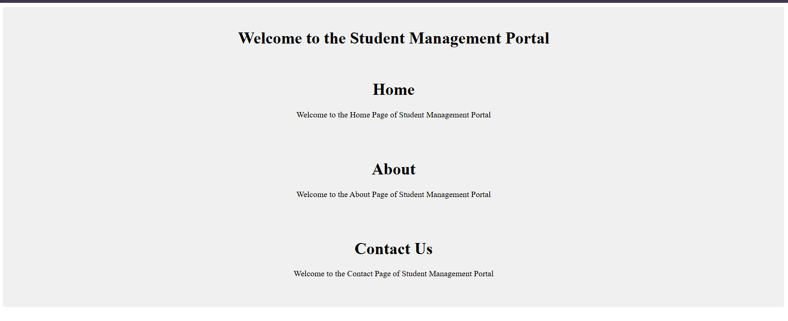

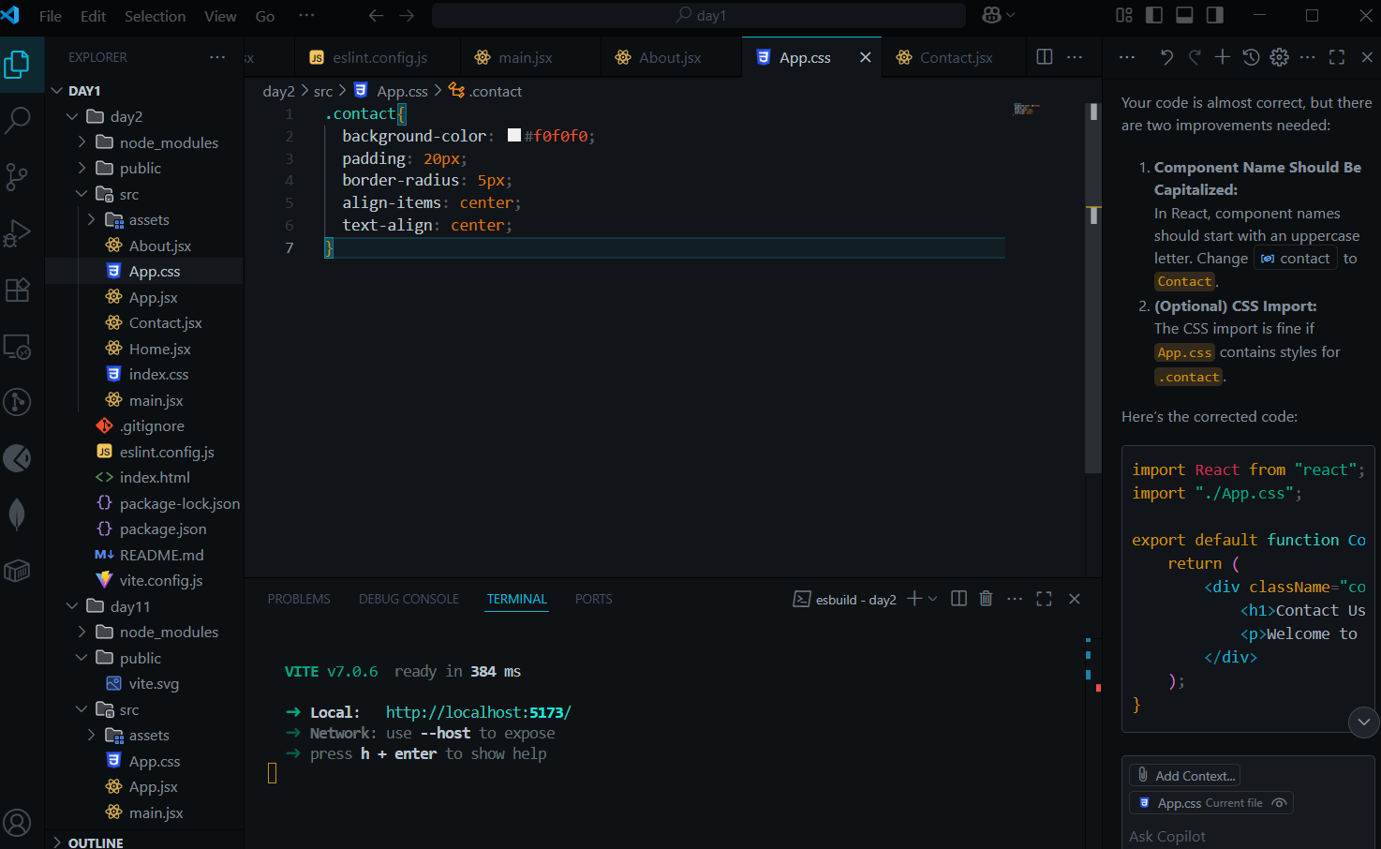  
  
  
3.Create a react app for Student Management Portal named scorecalculatorapp and create a function component named “CalculateScore” which will accept Name, School, Total and goal in order to calculate the average score of a student and display the same.:

Program:

CalculateScore.jsx:

import React from 'react';

import '../Stylesheets/mystyle.css';

function CalculateScore({ name, school, total, goal }) {

const average = (total / goal).toFixed(2);

return (

<div className="score-card">

<h2>Student Score Calculator</h2>

<p><strong>Name:</strong> {name}</p>

<p><strong>School:</strong> {school}</p>

<p><strong>Total:</strong> {total}</p>

<p><strong>Goal:</strong> {goal}</p>

<p><strong>Average:</strong> {average}</p>

</div>

);

}

export default CalculateScore;

App.jsx:  
import React from 'react'

import './App.css'

import CalculateScore from './Components/CalculateScore'

function App() {

return (

<div>

<CalculateScore

name="Arun"

school="Saveetha Engineering College"

total={400}

goal={500}

/>

</div>

)

}

export default App

App.css:  
#root {

display: flex;

justify-content: center;

align-items: center;

height: 100vh; /* full viewport height */

margin: 0;

}

.score-card {

border: 2px solid #444;

padding: 16px;

margin: 16px auto; /* auto margin horizontally */

border-radius: 8px;

background-color: #f9f9f9;

width: 300px;

font-family: Arial, sans-serif;

}

Output:  
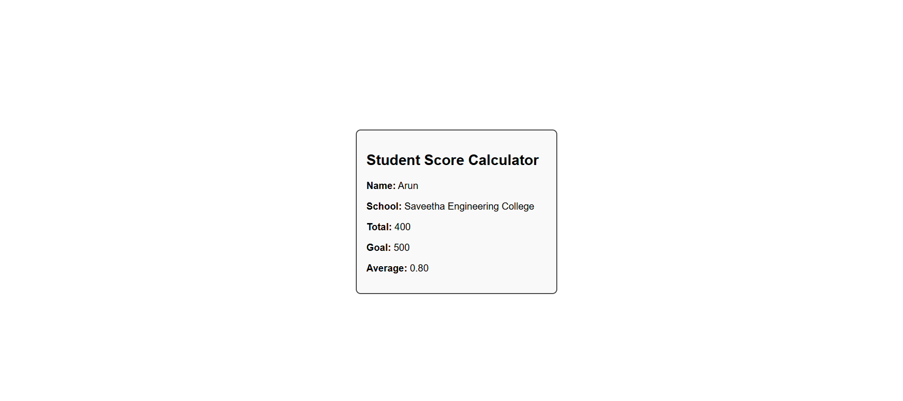

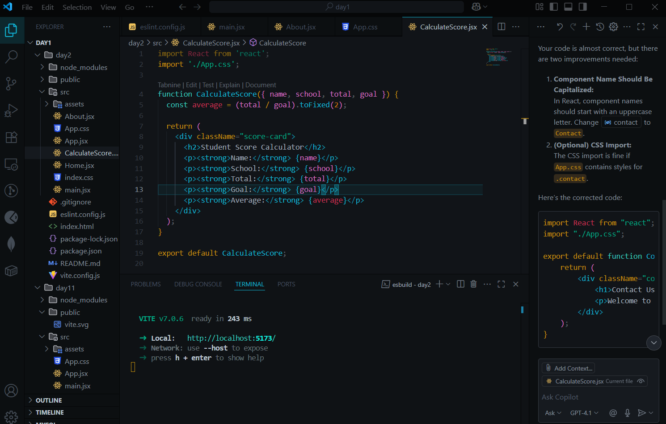

4. Create a new react application using *create-react-app* tool with the name as “blogapp”

App.jsx

import React from "react";

import "./App.css";

import Posts from "./Posts";

function App() {

return (

<div>

<Posts />

</div>

);

}

export default App;

[Post.js](http://post.js)

// src/Post.js

class Post {

constructor(userId, id, title, body) {

this.userId = userId;

this.id = id;

this.title = title;

this.body = body;

}

}

export default Post;

[Posts.js](http://posts.js)

import React from "react";

import Post from "./Post";

class Posts extends React.Component {

constructor(props) {

super(props);

this.state = {

posts: [],

error: null

};

}

loadPosts = async () => {

try {

const res = await fetch("https://jsonplaceholder.typicode.com/posts");

const data = await res.json();

const postObjects = data.map(

(p) => new Post(p.userId, p.id, p.title, p.body)

);

this.setState({ posts: postObjects });

} catch (err) {

this.setState({ error: err });

}

};

componentDidMount() {

this.loadPosts();

}

componentDidCatch(error, info) {

alert("An error occurred in Posts component: " + error);

}

render() {

const { posts } = this.state;

return (

<div>

<h2>Blog Posts</h2>

{posts.map((p) => (

<div key={p.id}>

<h3>{p.title}</h3>

<p>{p.body}</p>

</div>

))}

</div>

);

}

}

export default Posts;

OUtput:

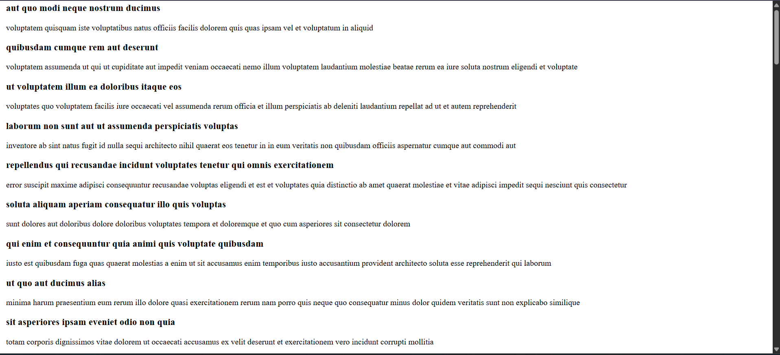

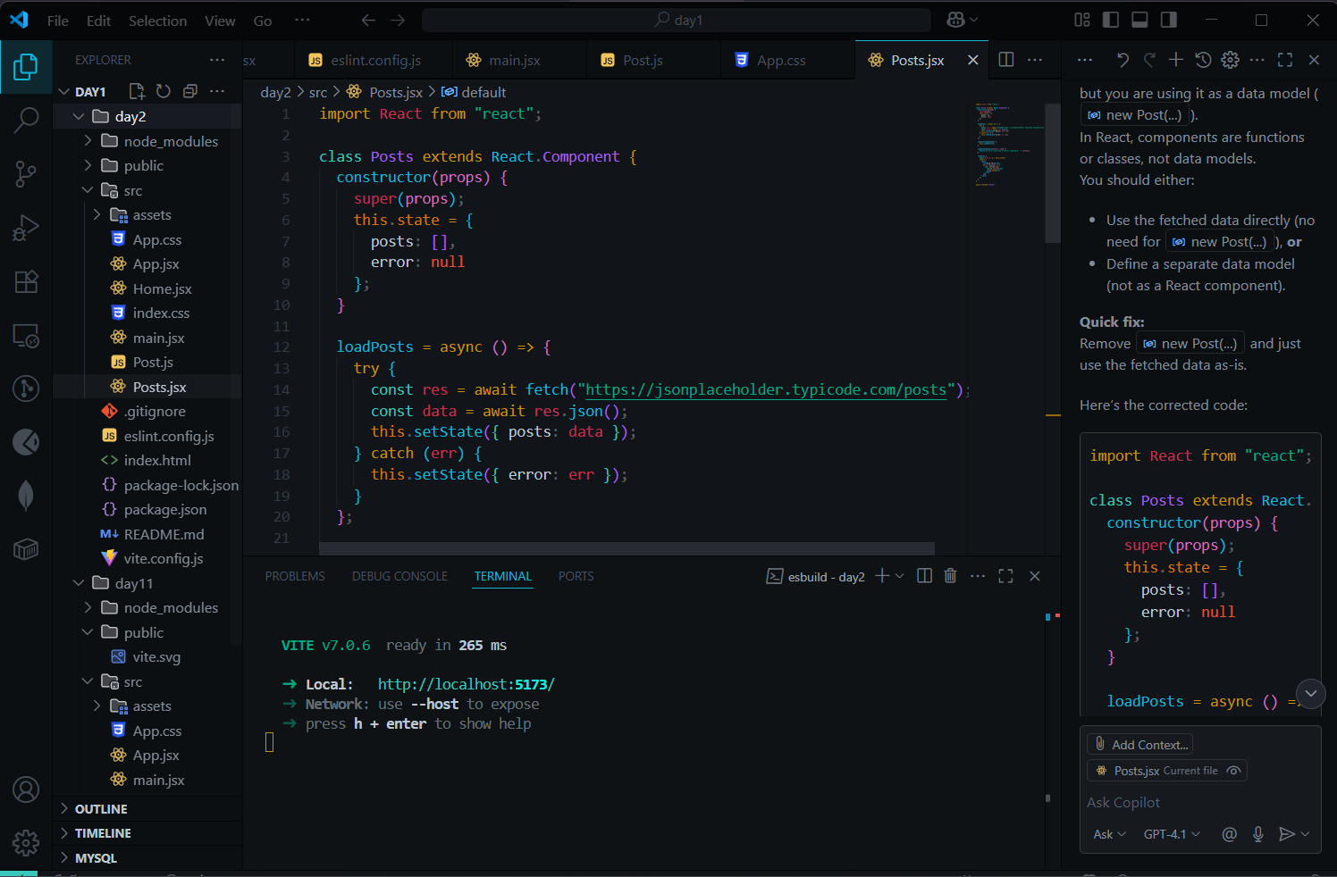

5. My Academy team at Cognizant want to create a dashboard containing the details of ongoing and completed cohorts. A react application is created which displays the detail of the cohorts using react component. You are assigned the task of styling these react components;

APP.jsx

import React from "react";

import CohortDetails from "./CohortDetails";

function App() {

const cohorts = [

{ name: "React Basics", status: "ongoing", mentor: "John Doe" },

{ name: "Node.js Advanced", status: "completed", mentor: "Jane Smith" },

];

return (

<div>

<h2>Cohort Dashboard</h2>

{cohorts.map((c, index) => (

<CohortDetails key={index} cohort={c} />

))}

</div>

);

}

export default App;

CohortDetails.jsx:

import React from "react";

function CohortDetails({ cohort }) {

const statusStyle = {

color: cohort.status === "ongoing" ? "green" : "blue",

};

return (

<div style={{

border: "1px solid black",

borderRadius: "10px",

margin: "10px",

padding: "10px 20px",

width: "300px",

display: "inline-block"

}}>

<h3 style={statusStyle}>{cohort.name}</h3>

<dl>

<dt>Status:</dt>

<dd>{cohort.status}</dd>

<dt>Mentor:</dt>

<dd>{cohort.mentor}</dd>

</dl>

</div>

);

}

export default CohortDetails;

Output:

